Java Programming Assignment 1
Question 1:
Write a Java program that demonstrates the use of variables and data types. The program should use variables of different data types (int, double, char, boolean, String) and perform basic operations such as addition, subtraction, multiplication, and string concatenation.
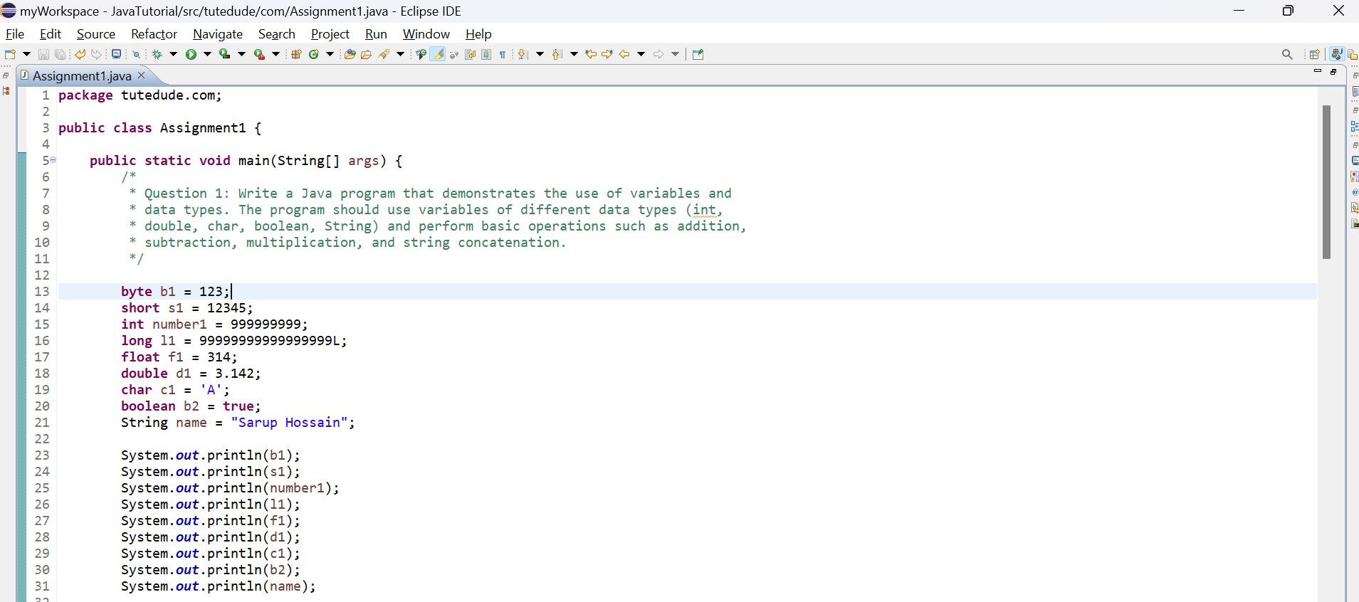
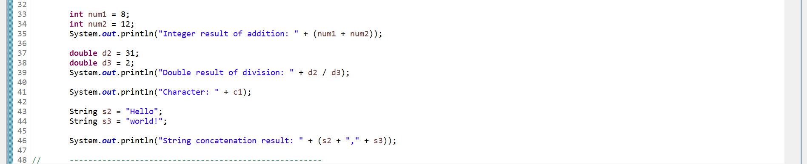
Output:
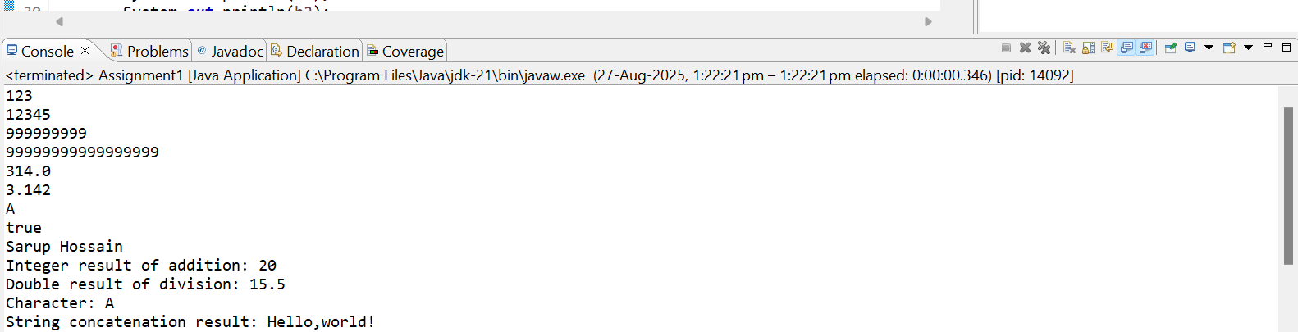

Question 2:
Write a Java program that creates an array of integers and performs the following operations: - Assign values to the array
- Find the sum and average of the array elements
- Find the largest and smallest element in the array
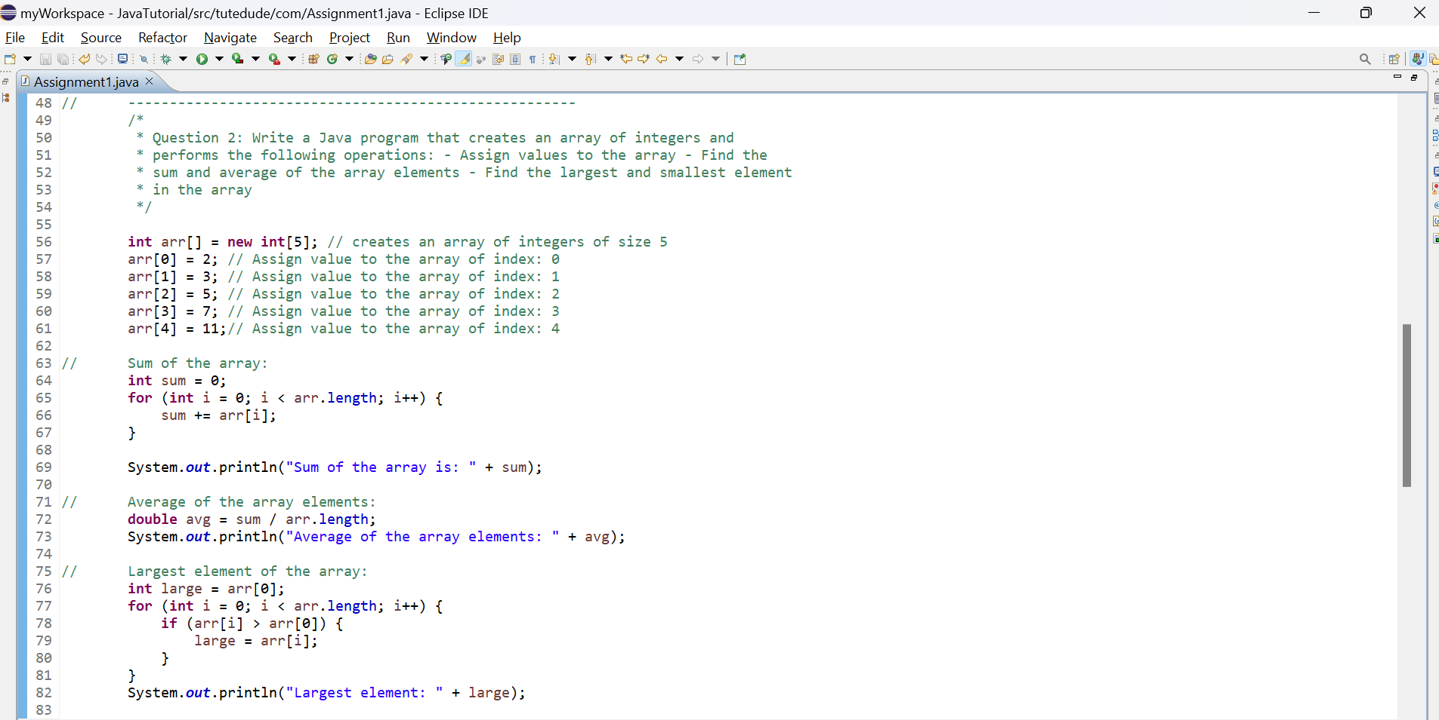
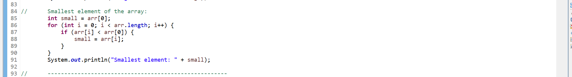

Output:
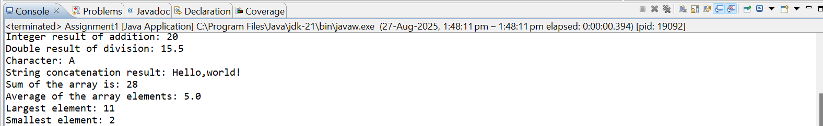

Question 3:
Write a Java program that uses If-Else and Nested If-Else statements to determine whether a person is eligible for voting. A person is eligible to vote if their age is greater than or equal to 18. Additionally, if the age is above 18, check whether the person has valid identification to vote. Use nested If-Else to handle these conditions.
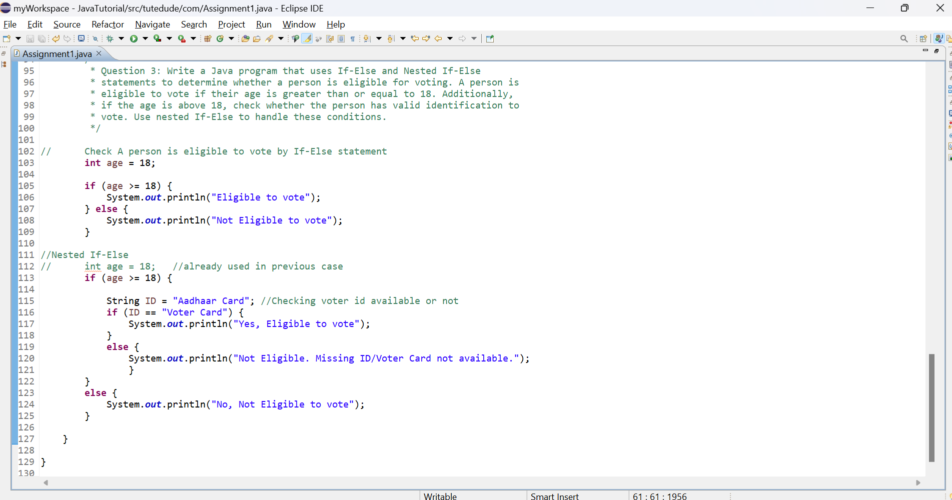

Output:
